Problem 1:

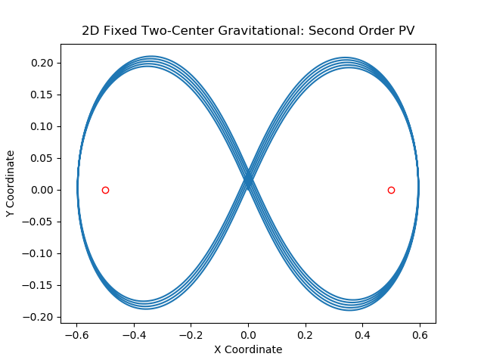
For a projectile fired fromwith velocity

For a projectile fired fromwith velocity
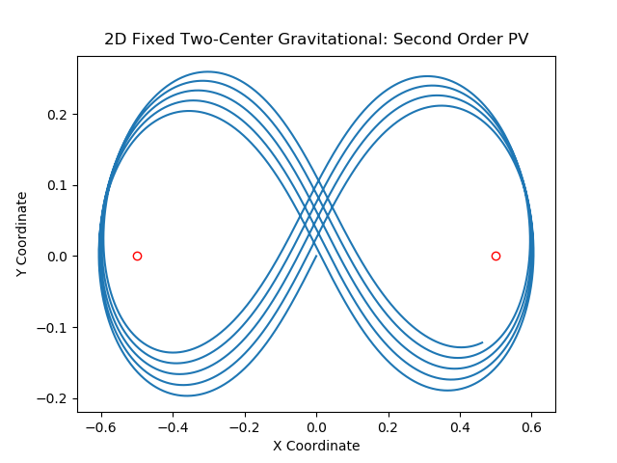
Problem 4:

Implementing the fourth order FR algorithm withand velocityfor the restricted three-body problem, we find:
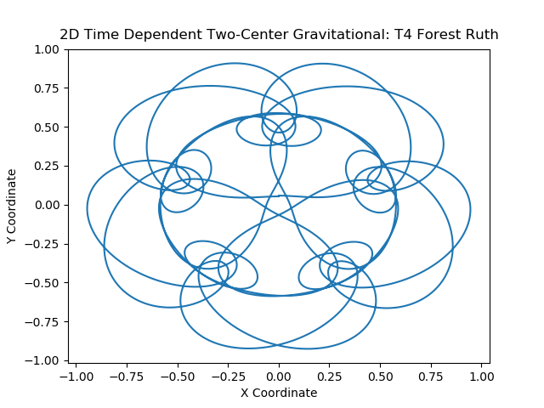
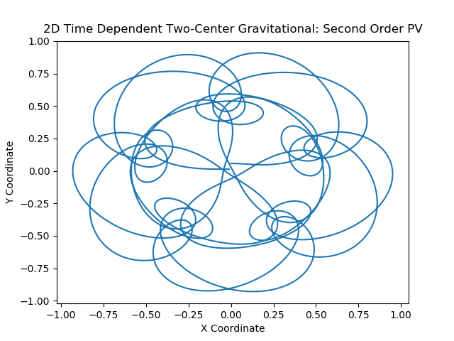
For the second-order Position-Verlet algorithm, using the same initial conditions, we find:

Problem 5:

In the co-rotating frame, our FR algorithm is presented as follows:
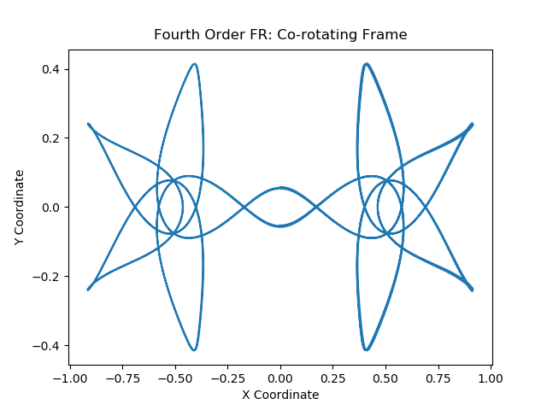
Choosingand velocityas our new initial conditions in an attempt to witness chaotic behavior reveals the following in the co-rotating frame:

